**Variables:**

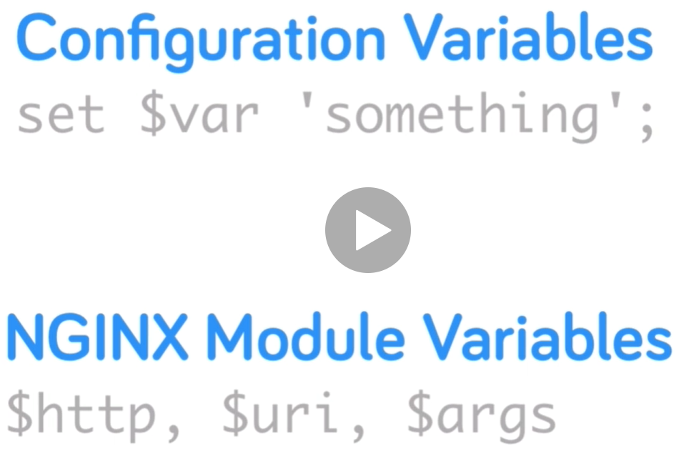

* We can find the nginx variables in nginx website documentation.

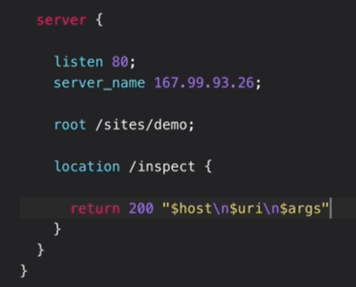

* We can add the variable as above. Then save and reload the configuration
* After this, we can use “/inspect” in URL to see the host name as below.

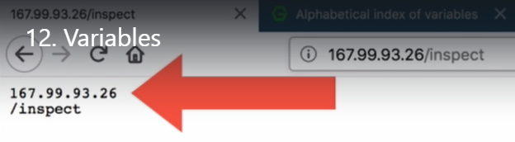

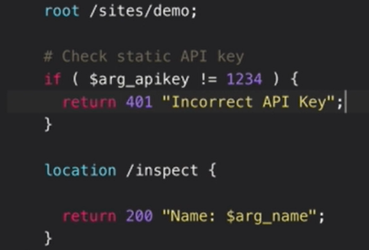

* We can set the if command as well in config file as above.
* With that, we can only access the web page by passing the condition in URL as below.

